Chapter 7 - ANALYSIS

Symptoms of large problems:
• Data or info doesn't flow as intended (too many/too few/wrong people receive it)
• Bottlenecks in the processing of forms result in slowed or stopped work
• Access to online forms is cumbersome. Web forms must be printed out & faxed or sent rather than submitted electronically.
• Unnecessary duplication of work occurs because employees are unaware that info is already in existence on another form that they do not receive.
• Employees lack understanding about the interrelatedness of info flow. (i.e. that they do not know that their output work serves as input on for another person)

NEEDS
1. Identification and management of information/data/record flows.
2. Describing information/data/record flows.
3. Automating information/data/record flows.

METHODS
1. Work process analysis
2. Work Process Modelling-
--> Reasons
a. Context diagram
b. Use case diagram
c. Logical Data Flow Diagram
d. Use case scenario
e. Physcial Data Flow Diagram
f. CRUD Matrix
g. Event response table
h. DFD fragments
3. Business rules
4. Work flow
5. Data repositories
6. Reverse engineering
7. Entity-relationship diagrams
8. Data dictionaries

SOURCES
1. Australian Technical Report
2. a. Ch. 7 in Laudon & Laudon
b. Ch. 2 in Laudon & Laudon
c. Ch. 7
d. Ch. 2
e - h. Ch. 7
3. Hoffer DBMS Ch. 4
4. WFMC Work flow reference model (Ch. 2)
5. Ch. 8 in Laudon & Laudon
6. Ch. 1 in Laudon & Laudon (6th edition)
7. Hoffer DBMS Ch. 3 / Kroenke Ch. 5
8. Ch. 8 in Laudon & Laudon

1. WORK PROCESS ANALYSIS
Definition: Work (business) process analysis is the analysis of sequence of steps or actions to produce a business outcome that complies with governing rules.

Types of analysis:
A. Contextual analysis: Helps locate the work process in its organizational context, thereby identifying the dependencies of the process.
B. Functional analysis: Top down decomposition
C. Sequential analysis: Flow of work mapping

A. CONTEXTUAL ANALYSIS
--> Typically a work process depends on
• Delegations
• Authorities
• Registers of users/employees
• System permissions of users/employees
which are often maintained by systems external to the work process.

--> Mapping such relationships (i.e. contextual analysis) is essential for both appraisal and determination of appropriate metadata to maintain the meaning of records and information over time.

1st step: Determine the scope
• A single activity in a discrete business unit?
• A whole function across the organization?
• An organization wide task or product?
2nd step: Identify the regulatory and organizational context (carried out via investigation method)
• For functional analysis: Broad legal requirements and organizational goals
• For sequential analysis: local procedures, business rules & organizational policies

B. FUNCTIONAL ANALYSIS
Divide the system into manageable smaller subsystems;
e.g. library modules in Pascal programming.
--> Functional analysis is a top down decomposition of
• Broad goals and objectives of the organization
• Functions that achieve those objectives
• Activities that form those functions
• Actions that make up those activities
• Recurring transactions --> Sequential analysis

--> Example areas to employ functional analysis
• Web site planning
• Subject classification of records

C. SEQUENTIAL ANALYSIS
--> Identifies and maps the sequence of actions or transactions of a work process
--> Identifies and maps their linkages/dependencies on other processes
--> It aims to account for every step in a work process.
--> It follows a chronological sequence.
--> It works on a smaller scale than the functional approach. --> i.e. at the transactional level.
--> It is work place and time specific.
--> It includes the record keeping processes themselves. [e.g. in processes which use forms, creation of the record. i.e. filling out the form and registering it initiates the sequence of actions and approvals required to perform the work. Completion of the record signals that the work process has been completed.]
--> Establishes
• the routine performance of the process (==>helps define business rules / data constraints)
• the most frequent variations, and
• identification other variations, which require non-standard intervention (i.e. ruling by exceptions)
--> Data/information/record analysis is the fundamental basis of procedure writing and documentation which are essential steps of ISO 9000 series of quality standards.
--> For example, this analysis and standardization can be applied to correspondence management, where sequential analysis may be utilized for design of templates and standard routes for tasks such as complaint handling or correspondence management at a broader level. This has the potential for development of office automation systems (i.e. workflow systems) which integrate the record keeping with the work tasks.
--> Record keeping ('data storage' in DFD terms) arising from any specific work process includes the documentation of the business rules, procedures and guidelines which inform that process and which are produced as an output of the analysis of the business process itself.

Both functional and sequential approaches to work process analysis may be employed in various combinations, depending on the purpose of the analysis. The components of the two approaches may be undertaken in various combinations, too, depending on the nature of the task and scale of the project. i.e. biri diğerine engel değil.

Workflow: Automation of work (business) process in whole or part, during which documents, information or tasks are passed from one participant to another for action according to a set of procedural rules.

2. WORK PROCESS MODELLING

Modelling = Visual depiction of the system.
In diagramming the flow of information, paperwork & decisions, work itself is the important element (in playscript analysis (used in observation) people are the important element)

Reasons for modelling
• Standard communication language within team.
• Better communication with users.
--> A picture is worth 1000 words.
--> Only 4 symbols. See fig. 7.1 on p. 218 for symbols and p. 219 for their meanings.

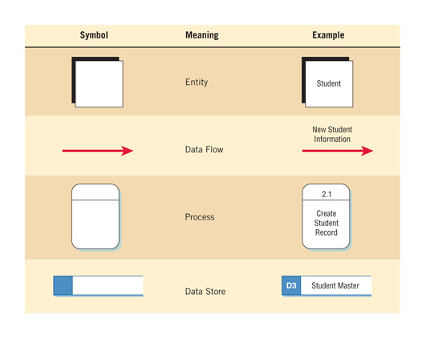

--> Visual memory is very strong.
• Helps workout systems requirements and any corrections to it at a later stage.
-->System requirements is the most difficult phase.
• Better understanding of the business by analysts.
--> Shows processing/transformation of data as they move along the system.
• Creates more stable systems
-->Good way of validating different parts of the system as you move along.
• Eliminates redundancies.
-->Forces you to think in an more systematic way. (Similar to designing a computer program.)
• Provides flexibility and maintenance.
-->Planning a construction vs. constructing without a plan (need to change walls, electrical system, plumbing, etc.)
• Provides easier maintenance via documentation.
-->Support people need it (often they are different people).
• Ensures data integrity and improves data quality.

a. Context diagram:
• Shows external entities and data flows to and from the system. Do not show any detailed processes or data stores.
• Input data flow from an external entitiy is called a trigger because it sarts the activities of a process.
• Output data flow to an external entitiy is called a response because it is sent as a result of some activitiy.

b. Use case diagram (Kullanım Şekli)
• It was originally produced to be used in object oriented UML.
• It shows the standard flow of events that describe standard system behaviour.
• It describes what the system does without describing how it is done. It uses a similar format to process specifications (described in Kendall Ch. 9)
• It is free of technical details.
• It is free of implementation details.
• It is a logical model.
• It is a model based on interactions and relationships of individual use cases.
• It is developed by the help of business experts to define system requirements.
• It partitions the way the system works into
--> behaviours
--> services
--> responses (use cases)
• It has got three elements:
-->An actor
--> A trigger
--> Actions triggered by that event
• It reflects how the system is seen by a user outside the system.
• It determines what is of value to the actors (or users) and what they want (i.e. system requirements)
• Actors are outsiders to the system who interact with it in a particular way. It can be a human, another system, or a device such as keyboard or a web connection.

Primary actors supply data or receive information from the system. Some of them interact with the system (and called sytem actors) but some of them (like business people) do not directly interact with the system but have a stake in it. They provide details on what the use case should do and a list of goals and priorities.
Supporting (secondary) actors keep the system running or provide other services. e.g. help desk, analysts, programmers, etc.

Developing use case diagrams:
1. Ask the users what the system should do for them (via interviews, JAD, etc.).
2. List who is involved with each of these actions/events (actors).
3. List responsibilities or services the use case must provide to actors or other systems.
4. Expand these via further analysis.

Behavioural relationships
(see fig 2.13 on p. 40 and fig 2.14 on p. 41)
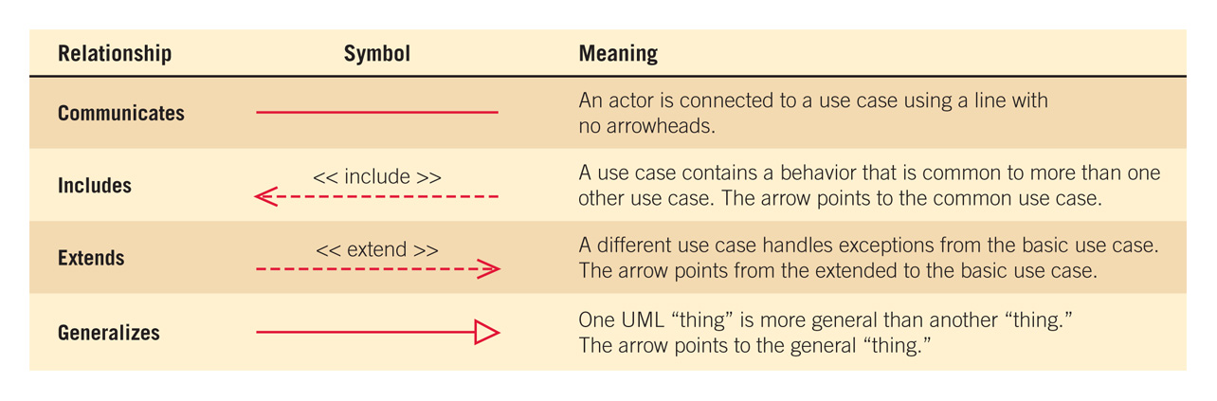

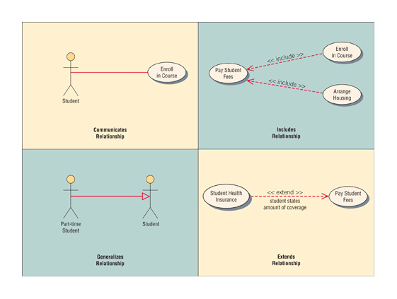
• Communicates: Shows what the actor benefits from the system (with a continuous line).
• Includes: Shows a behaviour that is common to more than one use case (with a dotted line and an arrow, where the arrow points to the common use case).
• Extends: Shows the variations or exceptions (with a dotted line and an arrow, where the arrow points to the routine case).
• Generalizes: Shows subsets (via a continuous line and an arrow, where the arrow points to the general thing).

c. Logical Data Flow Diagram
• Derive the logical data flow diagram by examining the flow of business activities in the current system and isolating unique business activities (functional analysis)
• Focus on the business and how the business operates. Describe the business events that take place and the data required and produced by each event.
• Draw Diagram 0: Show processes, but keep them general. Show data stores at this level.
• Create a child diagram for each of the processes in Diagram 0.
• Check for errors and make sure the labels you assign to each process and data flow are meaningful.

d. Use case scenarios
• Primary use case shows standard flow of events.
• Alternative paths show variations to the standard behaviours (e.g. what happens if an item is out of stock or if a credit company rejects a customer's requested purchase).(fig 2.16 on p. 44)
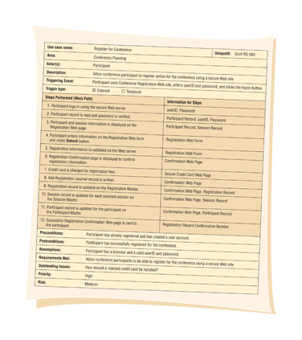
--> In addition to actors, list stake holders (individuals or organizations that are not actors but have some vested interest in the behaviour of the use case)
--> The "requirements met" field links the use case to user requirements or objectives defined at the "problem definion" stage.
-->"Information for steps" area may contain web pages, forms, database tables. records, etc.
--> "Risk"field shows whether there may be problems or difficulties in developing the use case.

Advantages of use case scenarios: See fig 2.17 on p. 46
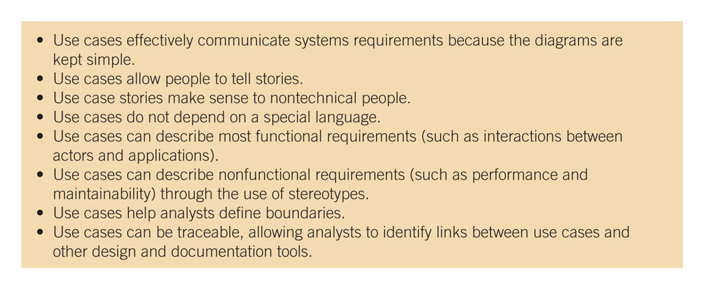
Prepare a different use case scenario for variations rather than using IF...THEN statements.

e. Physical data flow diagram
• It is not essential for the current system but it is a MUST for the alternative system.
• It distinguishes between manual and automated processes, describe actual files and reports by name, and add controls to indicate when processes are complete or errors occur.

Transition from Logical to physical data flow diagram
• Sequence processes that have to be done in a particular order (sequential analysis)
• Clarify which processes are manual and which are automated
• Add input, output, and processes to the logical data flow diagram.
1. Base elements: Data fields or elements that need to be keyed and stored in a file.
2. Derived elements: Elements that are not keyed but calculated or produced during a logical operation.
• Signify processes for adding, deleting, changing, and updating records
• Signify validation processes for ensuring accurate data input
• Add hardware, software, files and people involved in the system.
• Specify actual names of files and printouts
• Identify intermediate temporary data stores (often a transaction file or temporary database file used to store data between processes)
• Determine where the user intefaces should exist, the nature of the processes and necessary data stores.
• Add controls to signify completion of tasks or error conditions

f. CRUD Matrix: (Create, Read, Update & Delete; + Keying and Verifying)
A matrix of activities by people performing those activities, based on the actions listed above.
Shows where each of these processes occur in a system. See fig. 7b11 on p 229 for an example,
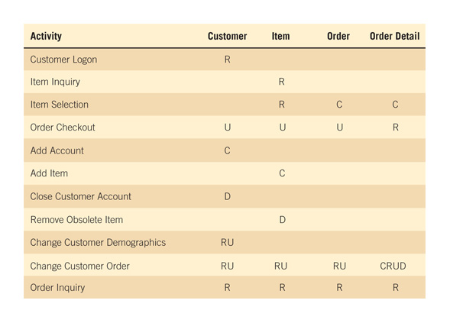
g. Event response table: A table of events by source, showing the source, trigger, activity, response and destination for each.(See fig. 7b12 on p. 230 for an example.)
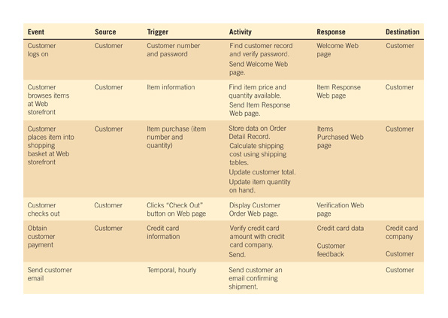
h. DFD fragments: Create DFD fragments for each event in an event response table. (See fig. 7.13 on p. 231 for an example.)
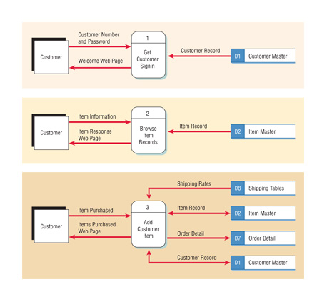
Partition the physical data flow diagram by separating or grouping parts of the diagram in order to facilitate programming and implementation.

Reasons for partitioning data flow diagrams
• Different user groups
• Timing
• Similar tasks
• Efficiency
• Consistency of data
• Security

