Chapter 2 - Organizational Style

Organization: System designed to accomplish predetermined goals and objectives through people and other sources that they employ.

Factors influencing info systems:
1. Levels of mgmt (there are decisions made at each level)
- Operations mgmt (make decisions using predetermined rules that have predictable outcomes when implemented correctly)
- Middle mgmt (short term planning and control)
- Strategic mgmt
2. Organizational structure
3. Organizational culture

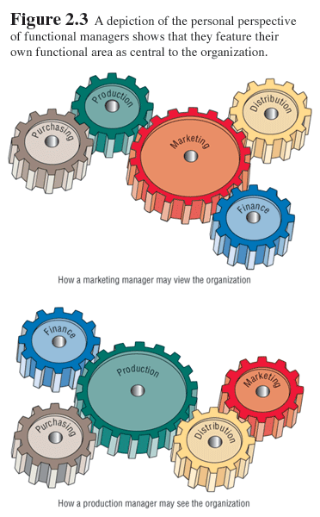

input-->process (change)-->output (try to discover what is being changed)
example process: verifying, updating and printing.

systems concept & interdependence of sub-systems (e.g. marketing vs. production views)-->fig. 2.3 on p. 31

Levels of mgmt
• Info needs at operations mgmt level
- clear-cut
- internal
- repetitive (quantitative)
- low-level (detailed, raw)
- captures current performance
- benefit from using online, real-time info resources
- timely
- past performance info/periodic info/external info--> rarely used
- current
- accurate
• Info needs at middle mgmt level
- both short and long-term info
- high need for real-time
- current info on performance against set standards
- internal
-high need for historical info
• info needs at strategic mgmt level
- external (new market trends, competitors)
- predictive
- high need for periodic info
- general, summarized info
- older
- estimate
- qualitative

Organizational structure
• Environmental factors:
1. Physical environment: population, demographic factors (like level of education and income)
2. Economic environment: market factors and competitors
3. Political environment: state and local government
4. Legal environment
5. Technological environment
• Inner environment
- Departments
- Openness (e.g. creative dept.) vs. closedness (e.g. defense dept.): free passage of resources (people, info, materials)
- Virtual? (working from home)
• Try to use grapevine to your advantage--> Look for a winner.

Organizational culture
Understanding and recognizing predominant organizational subcultures may help overcome the resistance to change. e.g. user training aimed at specific concerns or org.al subcultures may be devised

Results of improper planning before a new system is implemented:
• further customizations
• extended implementation time frames
• higher costs
• loss of user confidence

Data gathering methods:
• investigation
• observation
• interviews
• questionnaires
• prototypes

