Chapter 1 - Fundamentals

Factors of economy:
• Land,
• Labour,
• Capital
+ Information (not easily renewable, of strategic importance)

Info needs to be managed: It is not free. There are cost involved with its production, distribution, security, storage and retrieval.

Types of info systems:
-->fig. 1.1 on p. 2

Management functions:
• Planning,
• Organizing,
• Staffing,
• Directing
• Controlling

Roles of the systems analyst:
• Consultant,
• Supporting expert,
• Facilitator of change.
Qualities of the Systems Analyst:
• Problem solver (analyze and develop solutions),
• Communicator (organizer/coordinator),
• Computer literate,
• Trustworthy (ethical),
• Self disciplined and self motivated

Phases of Systems Development (life-cycle):
(May overlap or run concurrently.)
[Book implies these are valid for computerized systems. Not true. They are applicable to ALL systems.]
1. Identify problems, opportunites, objectives
2. Determine information requirements (understand the current system: What info needed by users to perform their job.)
3. Analyze system needs(discover the problems).
[Prepare a report summarizing:
- The administrative structure (get hold of organization chart + functions of each department. Investigate if there is a job description study done by the HR dept. or a strategic mgmt study
-->study of inner environment: strengths and weaknesses)
- Info produced (and needed) in this structure (get hold of existing file plan)
- Problem areas
- Solution alternatives (including the current system or a manual system) for each and every alternative.
- Advantages and disadvantages of each alternative.
- Cost/benefit analysis of each alternative.
- Recommended alternative (and why?)]
4. Design the recommended system.
5. Develop and document the system.
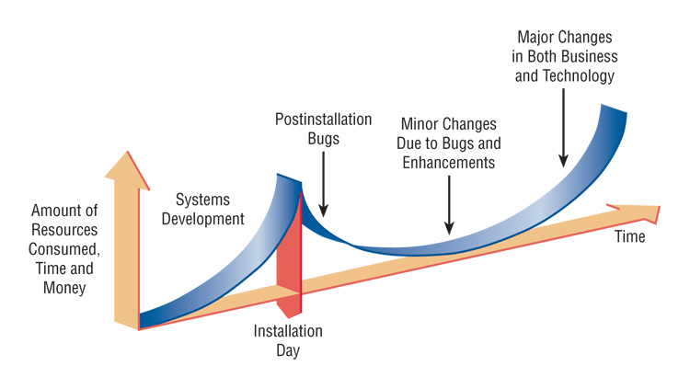
6. Test and maintain the system (maintenance of existing system takes 60% of time spent on the project.): alpha tests, beta tests, etc. -->fig. 1.5 on p. 15
7. Implement and evaluate the system: New needs may arise over time-->Strategic management

SW REVERSE ENGINEERING

• Used for extending the life of older programs (legacy SW)
• Code is examined, analyzed and converted into repository entities. i.e.:
* Data structures and elements that describe the files and records stored by the system
* Screen and report layouts
* Structure chart showing the hierarchy of modules in the program
* Database design and relationships

Advantages:
• Time for maintenance is decreased
• Documentation produced
• Structured programs created from unstructured or loosely structured computer code
• Future maintenance changes are easier because changes can be made at design level rather than code level
• Unused, obsolete parts of the code can be eliminated.

